Gourmet Coffee Fundraiser
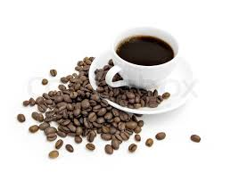

is happy to be offering our Wickedly Awesome coffee for our current fundraiser – our selection is delicious and priced to sell…!

This program is perfect for our group – 15 delicious choices because everyone has a different taste…! We have both K-cups and bags.

The profits from this fundraiser will go to

The official start date is , and the official completion date is . Please keep all order forms in the collection envelope provided, and make sure your name is on it. Personal checks, bank checks and money orders must be made out to: . All cash must be in the exact amount only. Please do not add sales tax.

Never allow students to solicit orders alone. They should always be in the company of a responsible adult.

Thank you for your support…!

